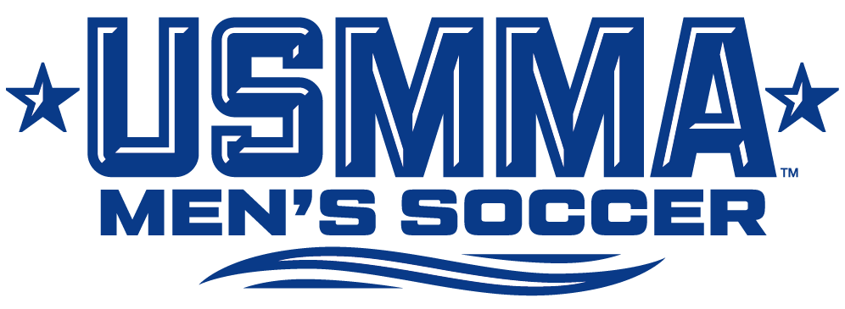

2025 Roster

# Name Yr. Pos. Ht. Wt. Hometown/High School
0 Minkyu Lim Fr. GK 6-2 182 Claremont, Calif./Servite
00 Evan Hoang-Le So. GK 6-0 205 Newburgh, N.Y./Newburgh Free Academy
1 Ethan Howell Jr. GK 6-5 195 Alexandria, Va./Hayfield Secondary
2 Cade Dailey So. D 6-1 190 Orange Park, Fla./Fleming Island
4 Cruz McDermott Jr. M 5-10 165 Palatine, Ill./Homeschooled
5 JP Park Fr. M 5-10 150 Falling Waters, W.Va./Spring Mills
6 Robert Derwin So. F 6-1 195 East Meadow, N.Y./East Meadow
7 Jack Ouellette Sr. M 5-11 165 Alexandria, Va./Hayfield Secondary School
8 Noe Macias Jr. M 5-7 165 Lansing, Mich./Waverly
9 Patrick Novotny Jr. F 5-11 165 Fort Worth, Texas/Keller Central
10 Drew Boukidis Sr. M 5-11 175 Charlotte, N.C./Covenant Day School
11 Brady Dillon Jr. D 5-10 185 Westminster, Md./Gerstell Academy
12 Andrew Hazlett So. D 6-0 170 Highlands Ranch, Colo./Valor Christian
13 Alex Hwang Fr. D 5-11 155 Centreville, Va./Westfield
14 Brendan Farrell Fr. M 5-11 158 Holbrook, N.Y./Sachem North
15 Blake Landreneau So. D/M 5-11 160 Lafayette, La./Southside
16 Tyson Mallas Sr. D 5-8 130 Los Angeles, Calif./Granada Hills Charter
17 Andrew Campbell So. M 5-9 140 Severna Park, Md./Severna Park
18 Max Oliver Fr. M 6-0 138 Warner Robins, Ga./Veterans
19 Tai Innerarity Fr. F 6-0 192 Port St. Lucie, Fla./Wolmer's Boys' (Jamaica)
20 Andrew Jung Jr. F 6-0 180 Fairfax, Va./Chantilly
21 Aiden Kennedy Fr. D 5-5 130 St. Johns, Fla./Allen D. Nease
22 Michael Hofstetter Sr. D 6-0 185 Deer Park, N.Y./Deer Park
23 John Germain Sr. M 5-8 160 Cornwall, N.Y./Cornwall Central
24 Colin Robertson So. F 6-2 165 Milford, Mich./Brighton
25 Jackson Justice Fr. D 6-0 185 Winchester, Va./John Handley
26 Charlie Safe Fr. F 6-0 195 Boise, Idaho/Borah
27 Quentin Lueck Jr. D 6-2 195 Bakersfield, Calif./Garces Memorial
28 Colin Mushorn Sr. D 6-1 205 Massapequa, N.Y./Massapequa
30 Cal Lutz So. M 6-2 170 Charlotte, N.C./South Pasadena
31 Ethan Schuette Fr. M 5-11 156 Gig Harbor, Wash./Gig Harbor
33 James Castoro Jr. GK 5-11 195 Garden City, N.Y./Garden City

Coaching Staff
Head Coach: Drew McCarthy (SUNY Maritime ’96) – Eighth Season
Athletic Trainer: Daniel Unverzagt, MS, ATC, EMT (Lyndon State, '97) – 14th Season

Pronunciations on next page.
Pronunciations (by syllable, emphasis on the BOLD CAPS)
#7 – Wool-LET #16 – It’s the word “malice”
#8 – NO-ee Mah-SEE-iss #19 – In-ee-ARE-it-ee (last 3 syllables are almost 2 syllables)
#10 – Boo-KEY-diss #28 – MUSH-horn
#15 – LAN-dren-no #27 – LUCK

